Test Case: tc001_SPX_Dev5_Crear_Nueva_Linea_Requisicion_Spot_Tipo_Cobro_CC
Step 1 - Enter username and password and click to button Enter : Credentials Entered
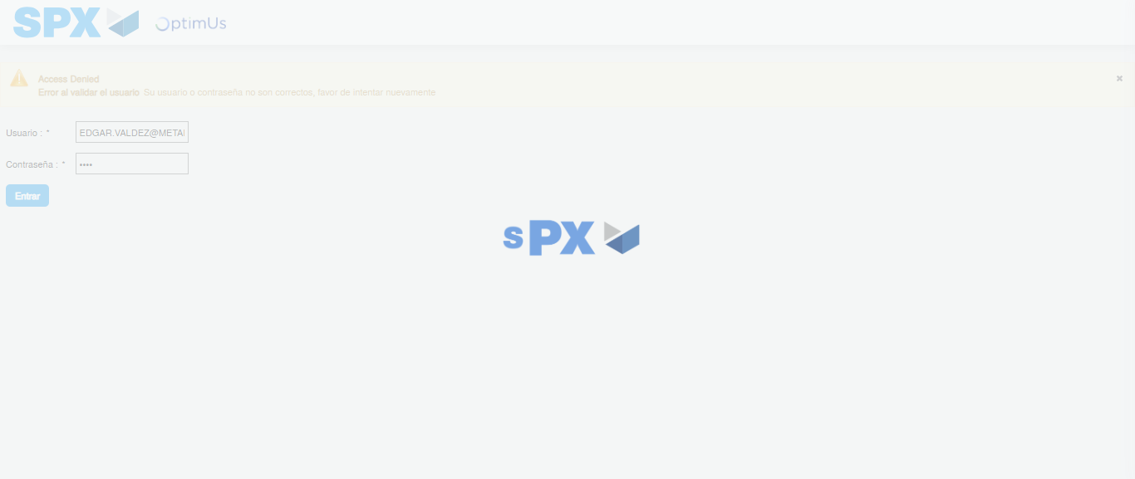Image file-name: QC_Testing-tc001_SPX_Dev5_Crear_Nueva_Linea_Requisicion_Spot_Tipo_Cobro_CC-1781563144992

Step 2 - Select to UEN and Access to Spot Buy Requisitions : UEN Correctly selected and Correct access
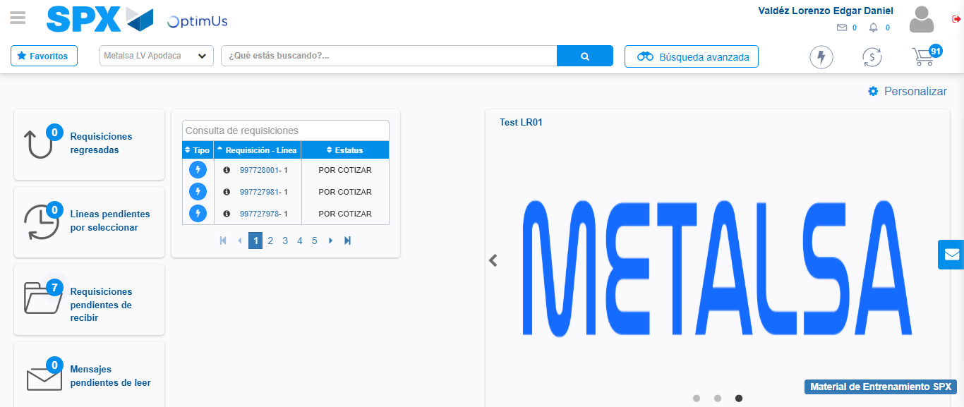Image file-name: QC_Testing-tc001_SPX_Dev5_Crear_Nueva_Linea_Requisicion_Spot_Tipo_Cobro_CC-1781563171740

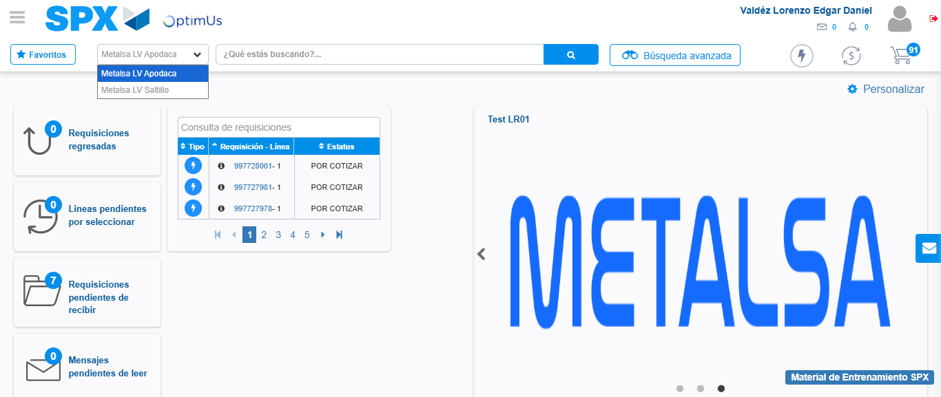Image file-name: QC_Testing-tc001_SPX_Dev5_Crear_Nueva_Linea_Requisicion_Spot_Tipo_Cobro_CC-1781563174248

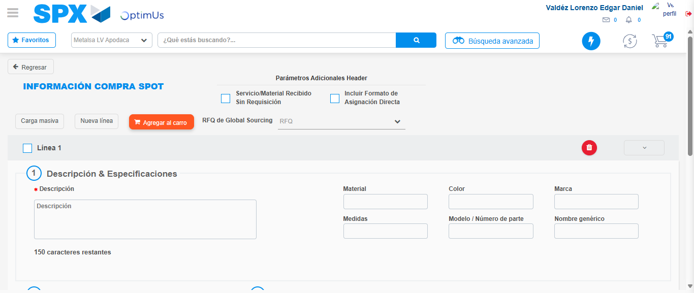Image file-name: QC_Testing-tc001_SPX_Dev5_Crear_Nueva_Linea_Requisicion_Spot_Tipo_Cobro_CC-1781563203367

Step 3 - Data Capture Spot Buy Requisition: Data captured correctly
Image file-name: QC_Testing-tc001_SPX_Dev5_Crear_Nueva_Linea_Requisicion_Spot_Tipo_Cobro_CC-1781563203605

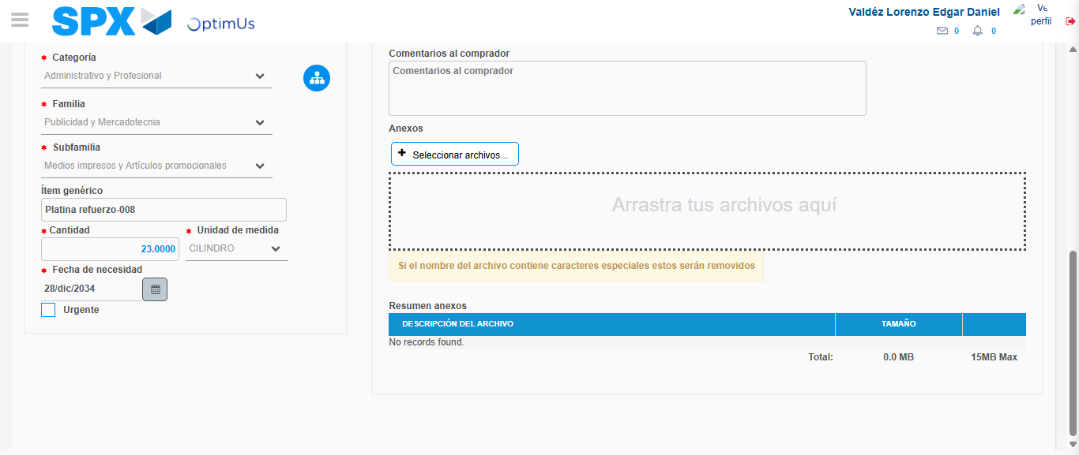Image file-name: QC_Testing-tc001_SPX_Dev5_Crear_Nueva_Linea_Requisicion_Spot_Tipo_Cobro_CC-1781563215129

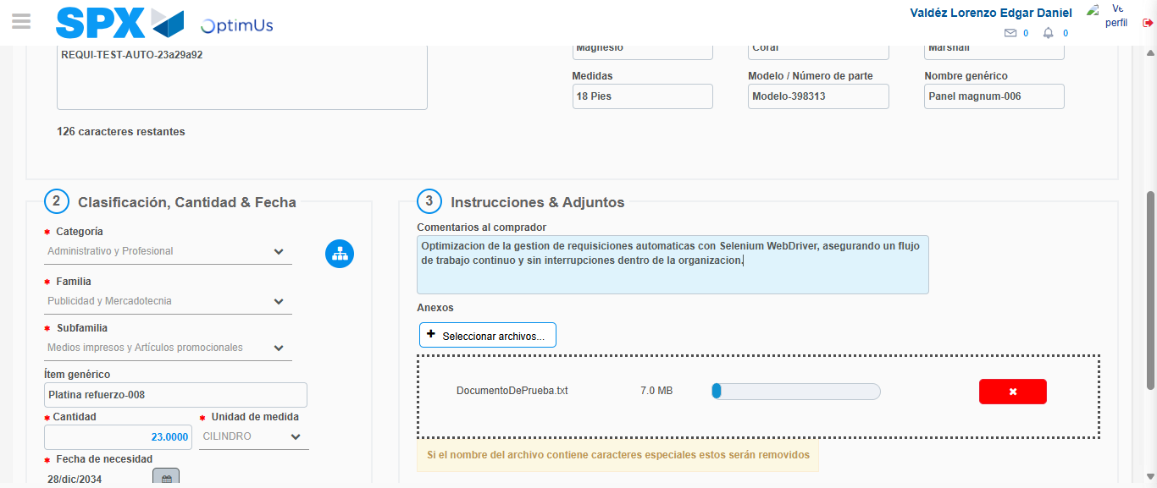Image file-name: QC_Testing-tc001_SPX_Dev5_Crear_Nueva_Linea_Requisicion_Spot_Tipo_Cobro_CC-1781563215905

Step 4 - Add new line and data capture second line: Line add correctly
Image file-name: QC_Testing-tc001_SPX_Dev5_Crear_Nueva_Linea_Requisicion_Spot_Tipo_Cobro_CC-1781563203605

Image file-name: QC_Testing-tc001_SPX_Dev5_Crear_Nueva_Linea_Requisicion_Spot_Tipo_Cobro_CC-1781563215129

Image file-name: QC_Testing-tc001_SPX_Dev5_Crear_Nueva_Linea_Requisicion_Spot_Tipo_Cobro_CC-1781563215905

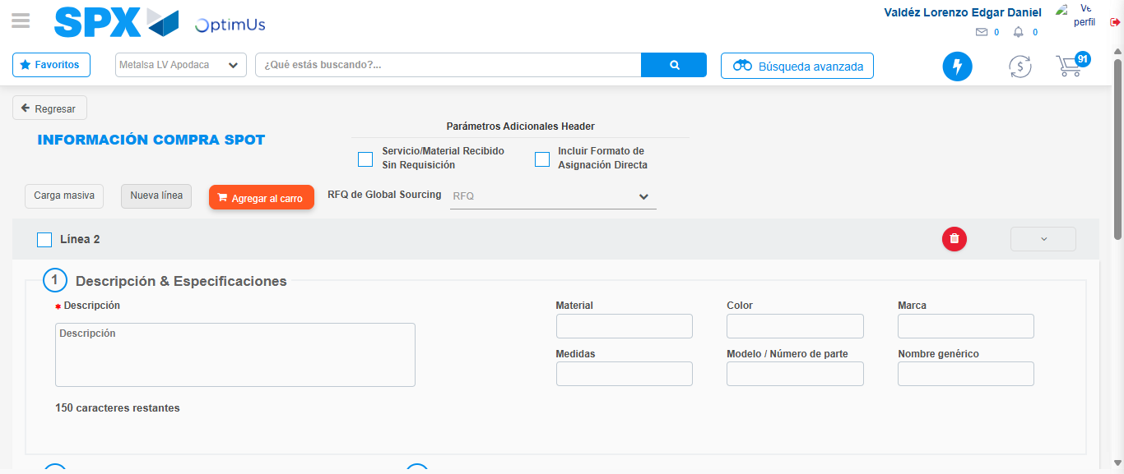Image file-name: QC_Testing-tc001_SPX_Dev5_Crear_Nueva_Linea_Requisicion_Spot_Tipo_Cobro_CC-1781563218211

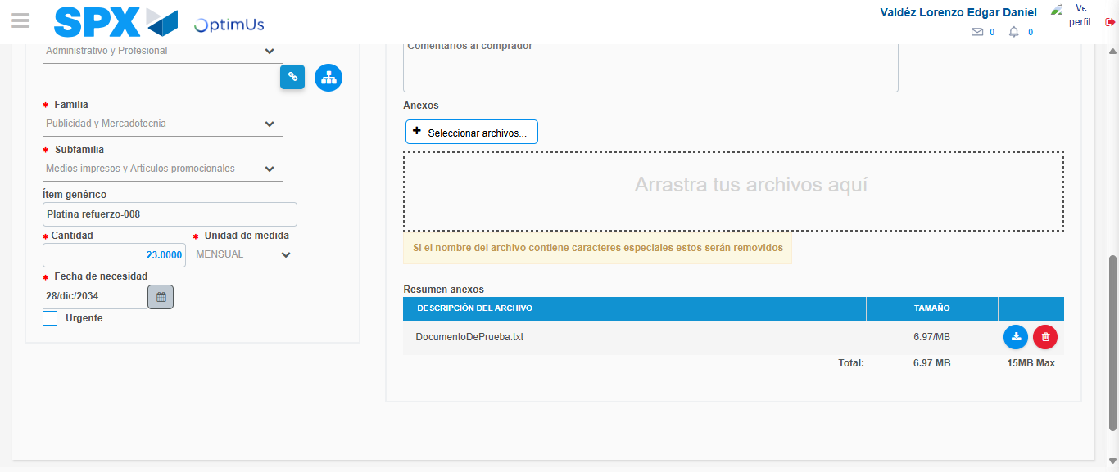Image file-name: QC_Testing-tc001_SPX_Dev5_Crear_Nueva_Linea_Requisicion_Spot_Tipo_Cobro_CC-1781563229500

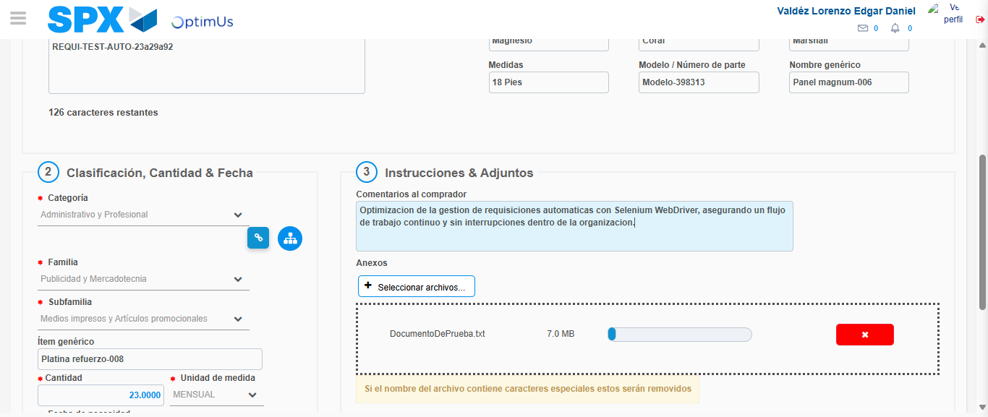Image file-name: QC_Testing-tc001_SPX_Dev5_Crear_Nueva_Linea_Requisicion_Spot_Tipo_Cobro_CC-1781563230262

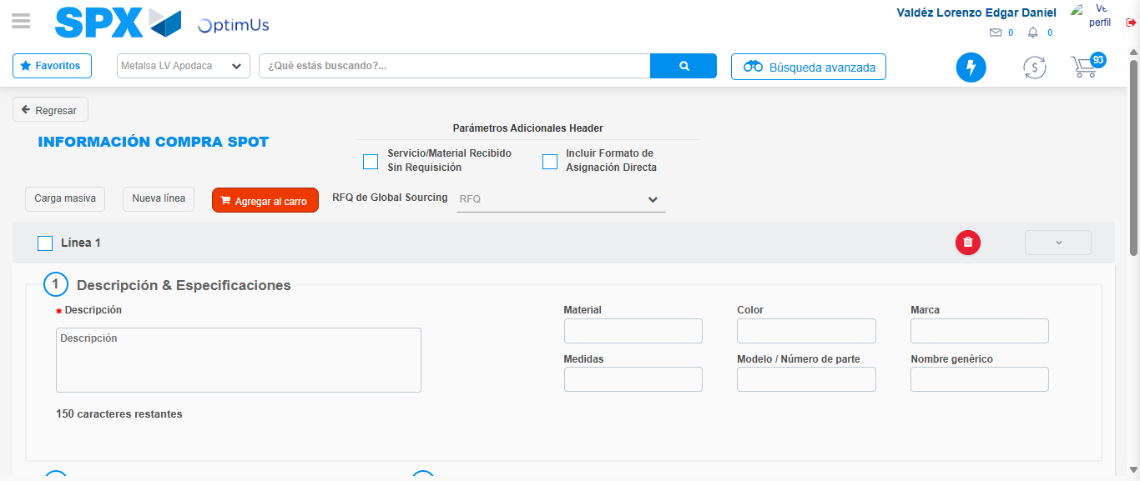Image file-name: QC_Testing-tc001_SPX_Dev5_Crear_Nueva_Linea_Requisicion_Spot_Tipo_Cobro_CC-1781563249615

Step 5 - Select to Requisition: Requisition Correctly selected
Image file-name: QC_Testing-tc001_SPX_Dev5_Crear_Nueva_Linea_Requisicion_Spot_Tipo_Cobro_CC-1781563249801

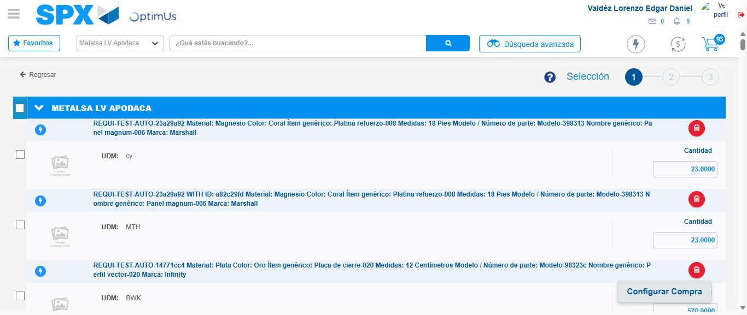Image file-name: QC_Testing-tc001_SPX_Dev5_Crear_Nueva_Linea_Requisicion_Spot_Tipo_Cobro_CC-1781563264045

Image file-name: QC_Testing-tc001_SPX_Dev5_Crear_Nueva_Linea_Requisicion_Spot_Tipo_Cobro_CC-1781563264246

Image file-name: QC_Testing-tc001_SPX_Dev5_Crear_Nueva_Linea_Requisicion_Spot_Tipo_Cobro_CC-1781563264450

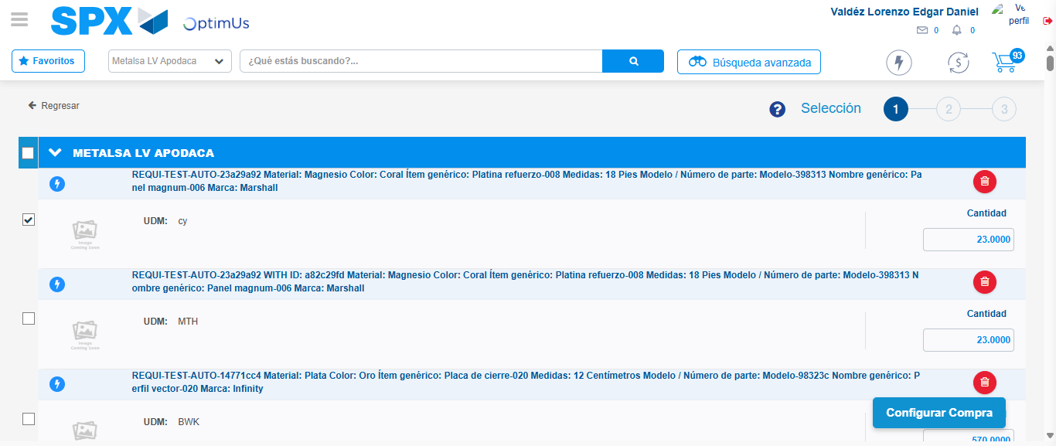Image file-name: QC_Testing-tc001_SPX_Dev5_Crear_Nueva_Linea_Requisicion_Spot_Tipo_Cobro_CC-1781563265846

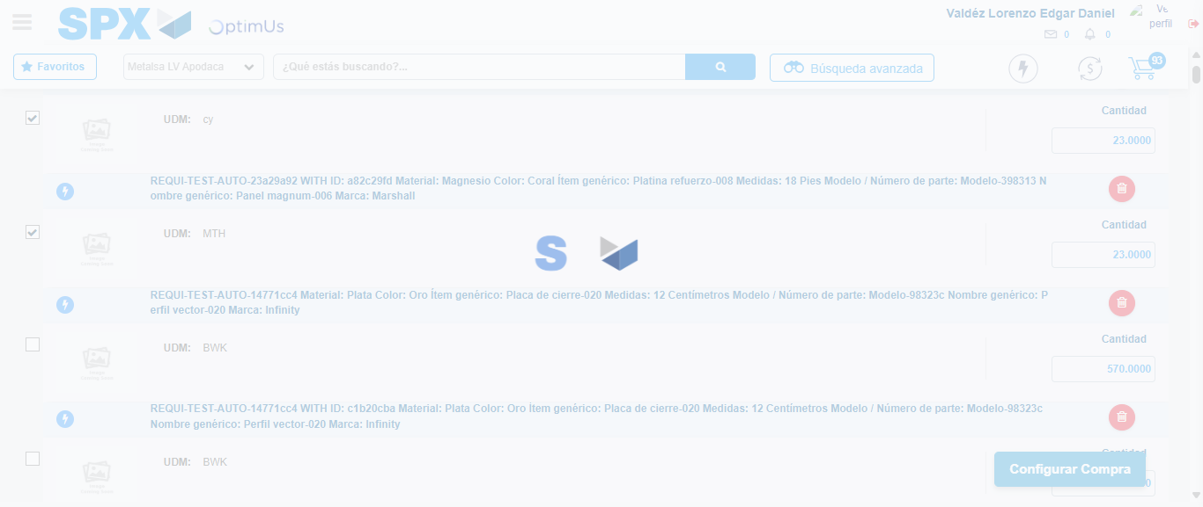Image file-name: QC_Testing-tc001_SPX_Dev5_Crear_Nueva_Linea_Requisicion_Spot_Tipo_Cobro_CC-1781563266747

Step 6 - Select Type Account For Requisition: Type Account Correctly selected
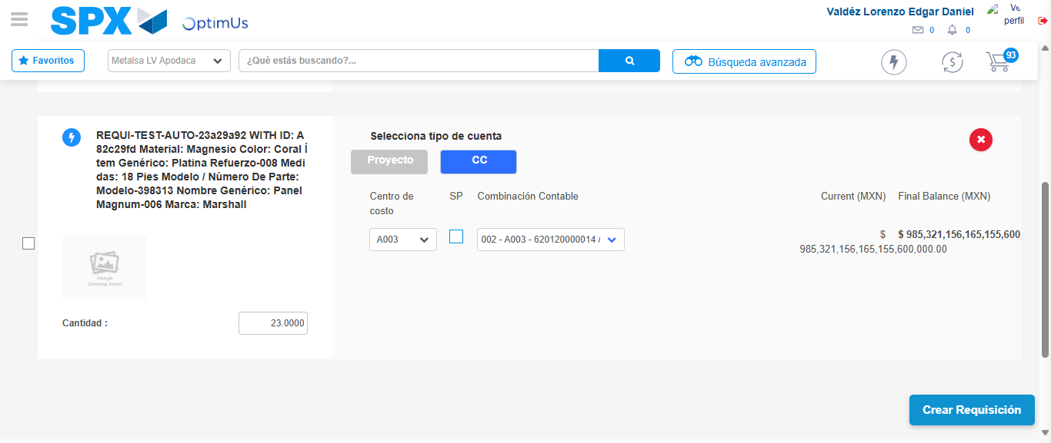Image file-name: QC_Testing-tc001_SPX_Dev5_Crear_Nueva_Linea_Requisicion_Spot_Tipo_Cobro_CC-1781563328667

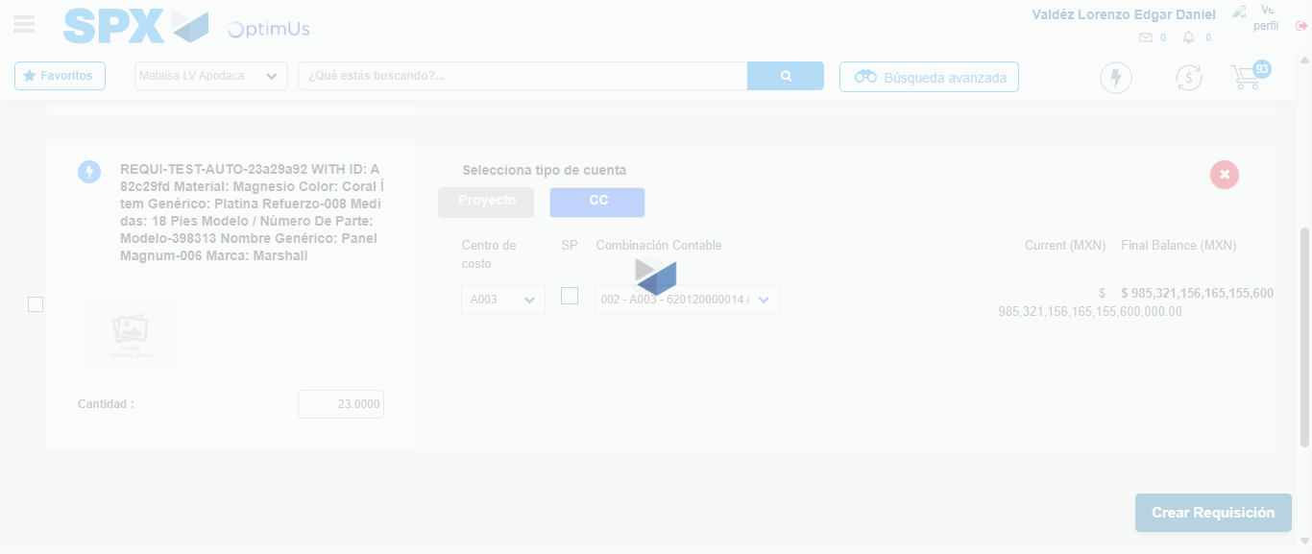Image file-name: QC_Testing-tc001_SPX_Dev5_Crear_Nueva_Linea_Requisicion_Spot_Tipo_Cobro_CC-1781563329061

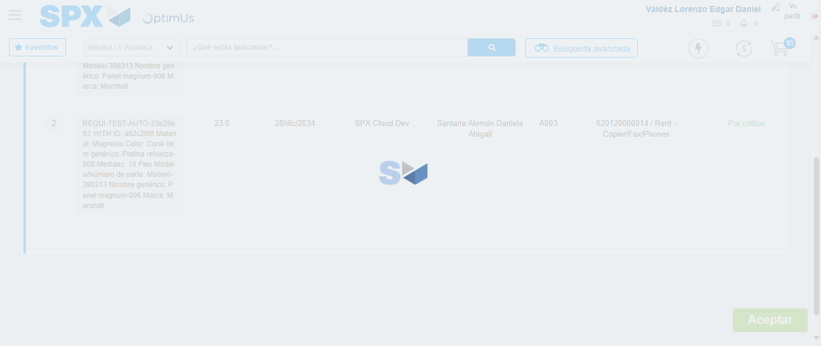Image file-name: QC_Testing-tc001_SPX_Dev5_Crear_Nueva_Linea_Requisicion_Spot_Tipo_Cobro_CC-1781563329276

Step 7 - Accept to Requisition: Requisition Accepted
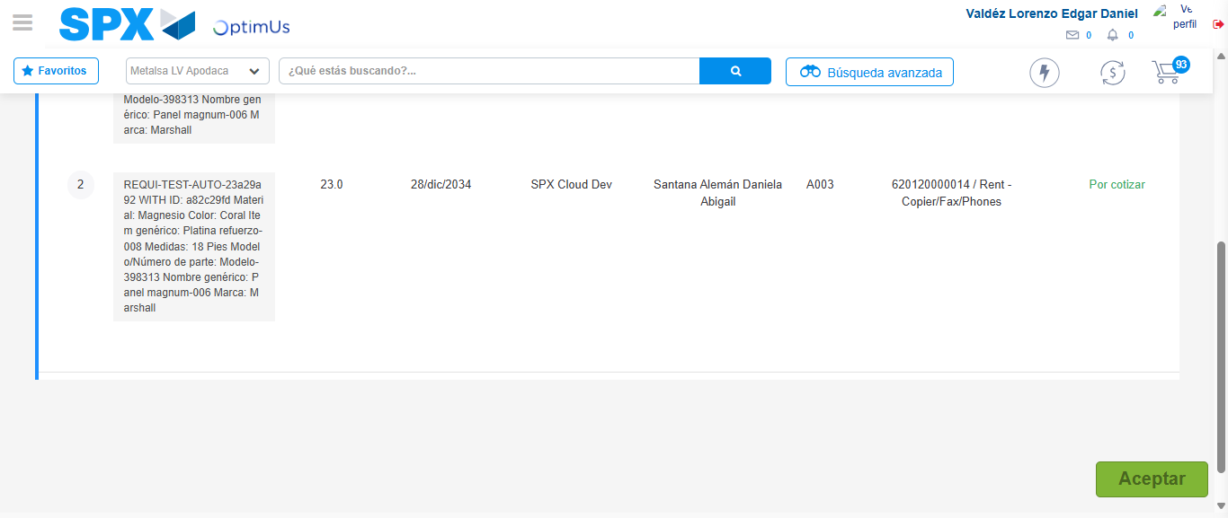Image file-name: QC_Testing-tc001_SPX_Dev5_Crear_Nueva_Linea_Requisicion_Spot_Tipo_Cobro_CC-1781563330072

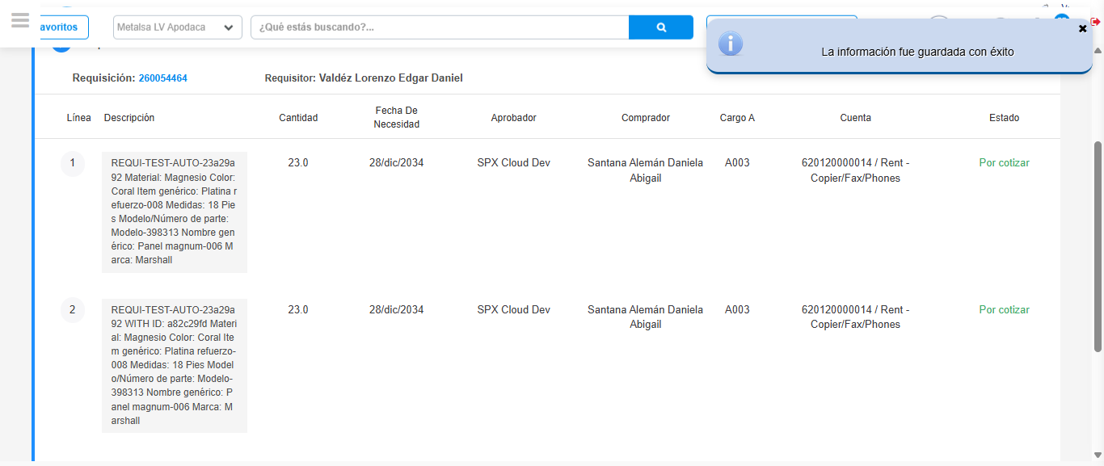Image file-name: QC_Testing-tc001_SPX_Dev5_Crear_Nueva_Linea_Requisicion_Spot_Tipo_Cobro_CC-1781563332510

Step 8 - Return to Main Page SPX : Return to Main Page SPX
Image file-name: QC_Testing-tc001_SPX_Dev5_Crear_Nueva_Linea_Requisicion_Spot_Tipo_Cobro_CC-1781563171740

Image file-name: QC_Testing-tc001_SPX_Dev5_Crear_Nueva_Linea_Requisicion_Spot_Tipo_Cobro_CC-1781563174248

Image file-name: QC_Testing-tc001_SPX_Dev5_Crear_Nueva_Linea_Requisicion_Spot_Tipo_Cobro_CC-1781563203367

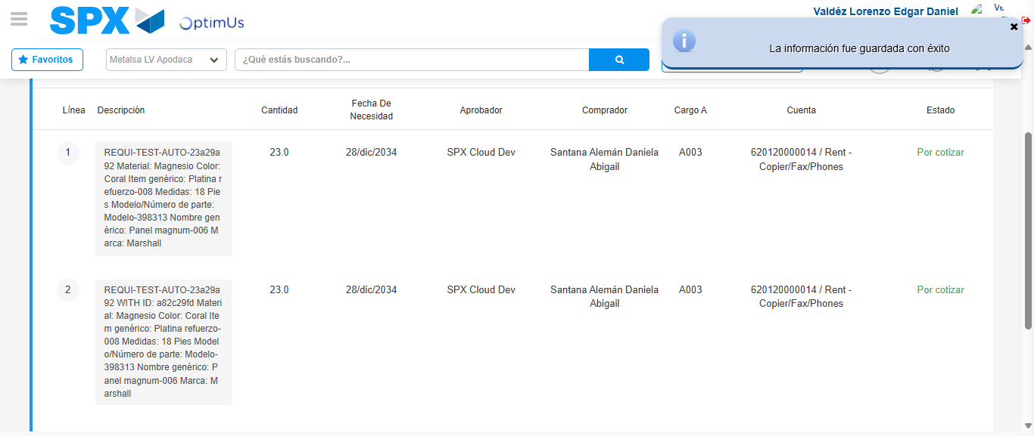Image file-name: QC_Testing-tc001_SPX_Dev5_Crear_Nueva_Linea_Requisicion_Spot_Tipo_Cobro_CC-1781563334770

Image file-name: QC_Testing-tc001_SPX_Dev5_Crear_Nueva_Linea_Requisicion_Spot_Tipo_Cobro_CC-1781563334933

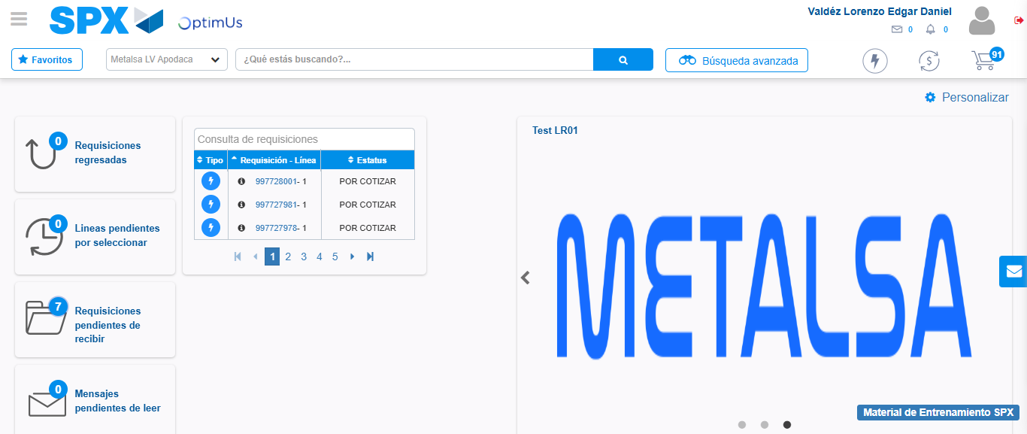Image file-name: QC_Testing-tc001_SPX_Dev5_Crear_Nueva_Linea_Requisicion_Spot_Tipo_Cobro_CC-1781563356093

Step 9 - Log Out : Log Out SPX
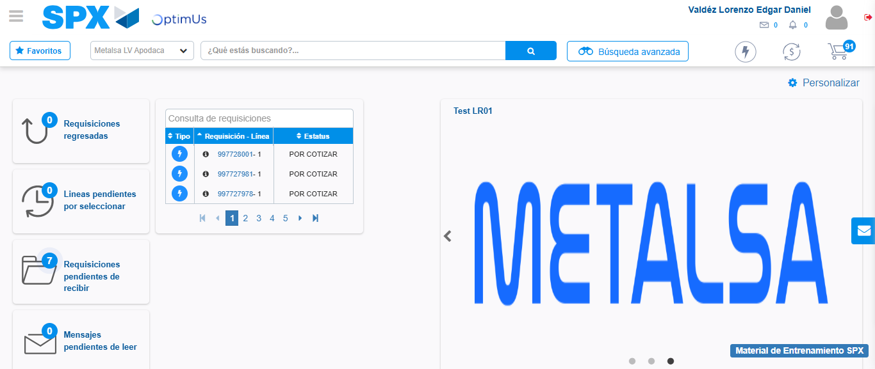Image file-name: QC_Testing-tc001_SPX_Dev5_Crear_Nueva_Linea_Requisicion_Spot_Tipo_Cobro_CC-1781563356359

